
Academia Ophthalmologica Internationalis

President

March 21, 2011

Professor Ioannis G. Pallikaris
School of Medicine, University of Crete
P.O 71003
Voutes, Heraklion, Crete

Dear Professor Pallikaris,

On behalf of the members of the Academia, it is my pleasure to inform you of your election to membership in the AOI. You are joining an organization with members from 33 countries, leaders in ophthalmology, for whom your membership is important.

You will bring great distinction to the AOI and I hope that you will find value from your membership and will look forward to attending AOI meetings on a regular basis.

Soon you will hear from our Secretary-General, Prof. Peter Wiedemann, who will give you some information about the AOI and your part in helping to make the organization flourish.

If I can be of help in any way, please let me know. In the meantime, congratulations, welcome to the AOI, and thank you in advance for what I know will be your many contributions to the Academia in the years ahead.

Sincerely,
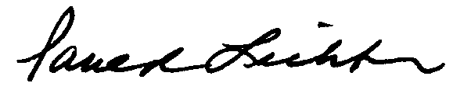

Paul R. Lichter, M.D.

PRL/tim
Paul R. Lichter, M.D.
University of Michigan
Department of Ophthalmology
& Visual Sciences
W.K. Kellogg Eye Center
1000 Wall Street
Ann Arbor, MI 48105, U.S.A.
Fax: 734-647-0247
Email:plichter@umich.edu

First Vice-President
Pran Nath Nagpal, M.D.
Retina Foundation
Aso Palov Eye Hospital
Near Under Bridge, Rajbhavan Road
Ahmedabad, India 380004
Fax: 91-79-286-6381
Email: pran@drnagpal.com

Second Vice-President
Hugh R. Taylor, AC, M.D.
Melbourne School of Population Health
University of Melbourne
207 Bouverie Street
Carlton, 3053, Australia
Fax:+61 3 9348 1827
Email: h.taylor@unimelb.edu.au

Secretary-General
Peter Wiedemann, M.D.
Dept. of Ophthalmology
University Leipzig
Klinik and Poliklinik for Augenheilkunde
Liebigstrabe 10-14, 04103
Germany
Fax: 0341-9721659
Email: peyew@t-online.de

Treasurer
Marie-José Tassignon, M.D.
University Hospital Antwerp
Department of Ophthalmology
Wilrijkstraat 10
B-2650 Edegem
Belgium
Fax: 32-3-825-1926
Email: marie-jose.tassignon@iuza.be

